**Topic:** Apollonius

**Notes on Topic:** Apollonius was another post-Archimedean mathematician worth studying  
Another contemporary of Archimedes   
He travelled to Alexandria to work on his masterpieces, the Conics  
The ellipses, parabola, and hyperbola   
The Conics was written in eight books, organized in the Euclidean fashion  
The first four giving general information, the last four giving some special cases  
Book 8 has been lost entirely  
When Johann Kepler (1571-1630) had his groundbreaking theory that planets travel in elliptical patterns around the sun, the importance of the conics was reaffirmed   
A century later the British scientist Edmund Halley devoted years of his life preparing the definitive edition of the Conics  
It stands as important as Euclid’s Elements and Archimedes’ work as one of the “landmarks of Greek mathematics”  
  
**insert excerpts from Conics**  
**insert diagrams of ellipses, parabola, hyperbola**

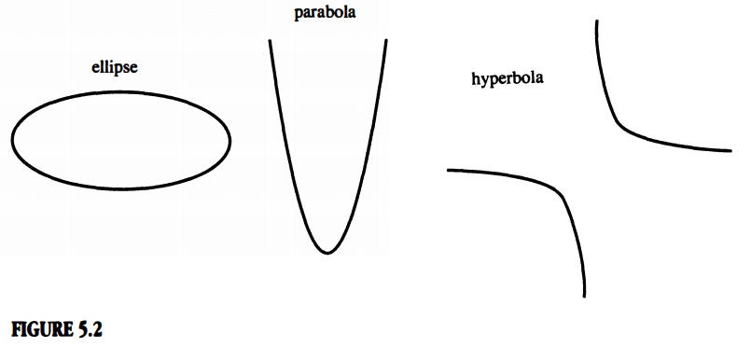

**Additional Suggested Reading**: Insert Here

**Assignment:** Insert Here